README – Grazioso Salvare Search-and-Rescue Dashboard
Developer: Nicole Hutto
Course: CS-340 – Client/Server Development
Project: Project Two – Interactive MongoDB Dashboard
Date: 12/11/2025

1. Required Functionality of the Project
The goal of this project was to complete the development of a fully functional, interactive dashboard for the international rescue animal training company, Grazioso Salvare. This dashboard allows users to filter, view, and analyze animals from the Austin Animal Center Outcomes dataset using a MongoDB database and Python Dash application.
The completed dashboard successfully demonstrates all required functionality:

Interactive Filter Options
The dashboard provides four filtering options that enable users to quickly identify dogs suitable for different types of rescue training:
- Water Rescue
- Mountain or Wilderness Rescue
- Disaster or Individual Tracking
- Reset (returns all available animals)
Selecting any filter dynamically updates the data table, pie chart, and geolocation map.
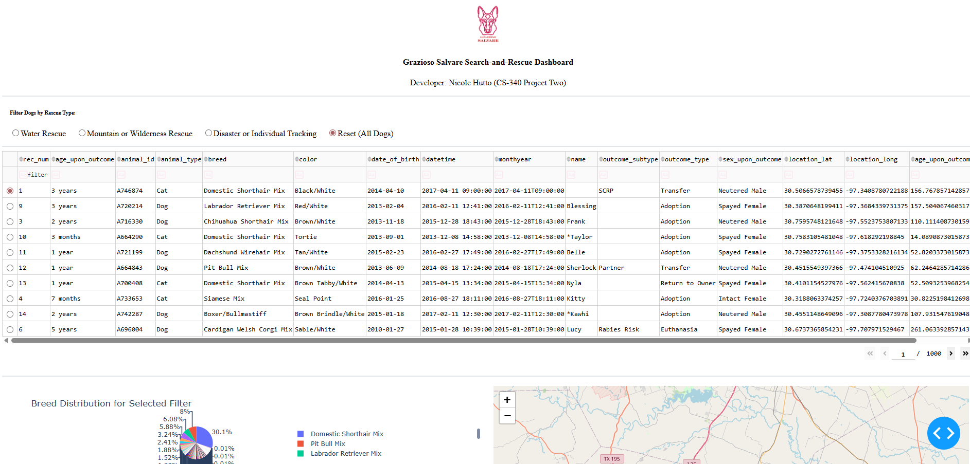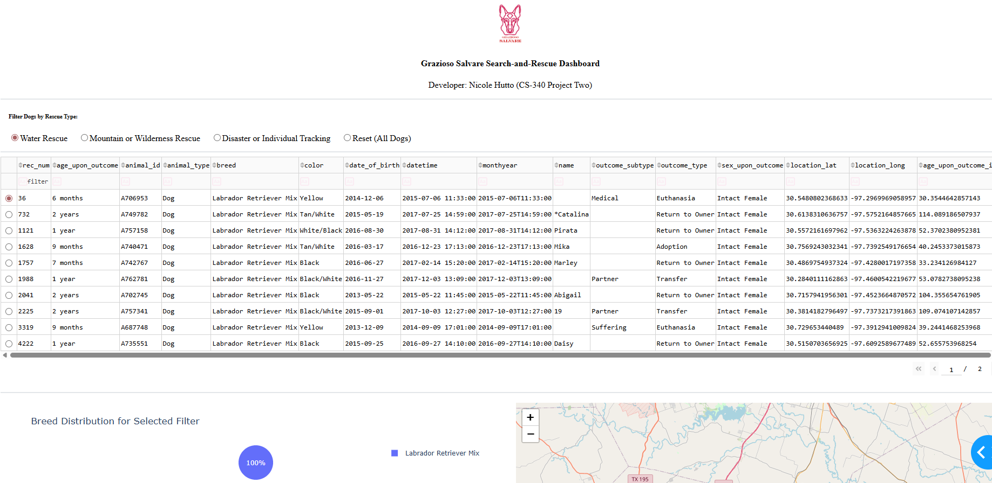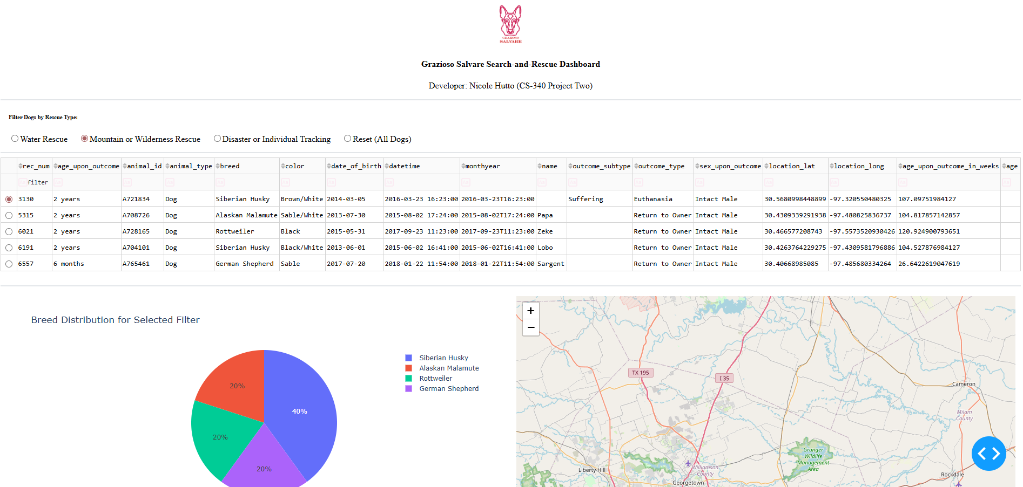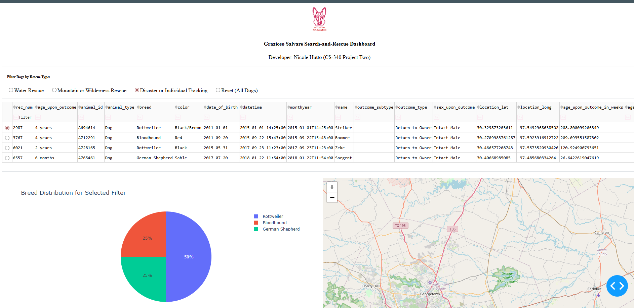

Interactive Data Table
The dashboard includes a fully interactive data table that supports:
- Sorting
- Native filtering
- Pagination
- Row selection
Selecting a row triggers updates to the geolocation component, pinpointing the animal on the map.
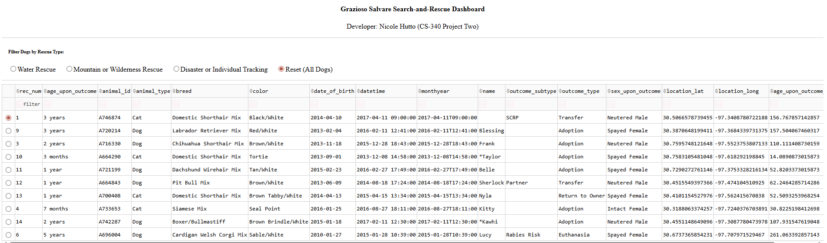
Dynamic Pie Chart
A pie chart displays the distribution of dog breeds based on the selected filter.
The chart updates live whenever the filter or table data changes.
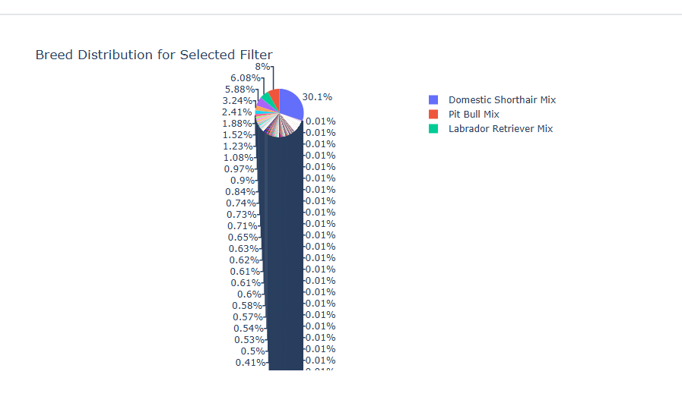
Geolocation Map
The dashboard uses Leaflet to render a dynamic map:
- Shows Austin, TX as the center
- Displays a marker at the dog’s recorded latitude/longitude
- Tooltip shows breed
- Popup shows the animal’s name
The map updates when a user selects a row in the data table.
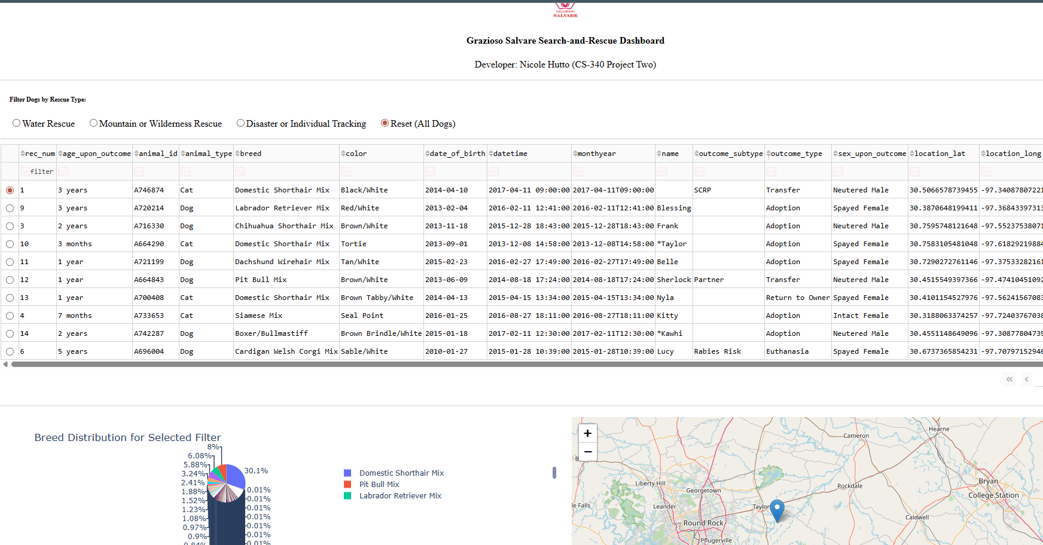
2. Tools Used & Rationale
MongoDB
MongoDB was used as the backend database because:
- It stores documents in JSON-like format, making it ideal for structured and unstructured data.
- It integrates easily with Python through PyMongo.
- Its flexible schema allows for simple filtering and query operations.
- It handles large datasets efficiently, which is necessary for the AAC animal outcomes data.

AnimalShelter CRUD Python Module
A custom CRUD module (created in Project One) provides:
- Secure connections to MongoDB
- Search queries for all rescue types
- A clean interface between the dashboard and the database
This module acts as the Model component of the MVC architecture.

Dash Framework (Plotly Dash)
Dash was used to implement the:
- View (HTML layout, data table, graphs, map)
- Controller (callbacks connecting user inputs to outputs)
Dash was chosen because:
- It supports true MVC separation
- It integrates seamlessly with Pandas and Plotly
- It allows components (charts, tables, maps) to update dynamically
- It renders directly in Jupyter Notebook and Codio environments

Additional Libraries
Library | Purpose
Pandas | Data manipulation & formatting
Plotly Express | Interactive pie chart
Dash Leaflet | Geolocation mapping
Base64 | Embedding the Grazioso Salvare logo
NumPy | Data operations as needed

3. Steps Taken to Complete the Project
- Reviewed the Dashboard Specification Document
Studied the UI/UX requirements and analyzed the rescue breed criteria needed for filtering.
- Connected the Dashboard to the MongoDB Database
Used the CRUD module from Project One to query data and return all records.
- Loaded and Cleaned the Data
Converted Mongo data to a Pandas DataFrame and removed unsupported _id fields.
- Created the Dashboard Layout
Added title, logo, filters, data table, pie chart area, and map area.
- Developed the Rescue Training Queries
Implemented specific MongoDB queries using breed lists and rules provided in the spec.
- Implemented Dashboard Callbacks
  - Updated table based on filter selection
  - Updated charts based on visible data
  - Updated map marker based on selected row
- Tested Dashboard Functionality
Verified correct behavior for all four filters and ensured smooth dynamic updates.
- Took Screenshots as required for rubric documentation.

4. Challenges Encountered & How They Were Overcome
Challenge 1: Handling MongoDB ObjectID Errors
The Dash data table cannot display MongoDB’s ObjectID type.
Solution: Removed _id column using df.drop() immediately after reading data.

Challenge 2: Ensuring Filters Returned Correct Animals
Rescue type queries required specific combinations of breed lists, sex, and age ranges.
Solution: Implemented breed lists and query dictionaries exactly as defined in the Rescue Type & Preferred Dog Breeds table.

Challenge 3: Callback Update Issues
Some Dash callbacks did not trigger at first due to missing input IDs or incorrect return types.
Solution: Ensured all callbacks returned properly structured Dash components and that input/output IDs matched layout components.

Challenge 4: Map Marker Errors
Map failed to update when certain rows lacked coordinates.
Solution: Ensured only rows with valid latitude/longitude indexes were used and defaulted to first row when necessary.

5. Instructions for Reproducing the Project
To run this dashboard:
- Install required Python packages:
- pip install dash dash-leaflet plotly pandas numpy
- Place the following in the same directory:
  - ProjectTwoDashboard.ipynb
  - AnimalShelter.py
  - Grazioso Salvare Logo.png
- Ensure MongoDB is running and accessible.
- Open the notebook and run all cells.
- The dashboard will appear inline using:
- app.run_server(mode='inline')

